Generating UCLA Login credentials:
- Navigate to https://accounts.iam.ucla.edu/#/

- Click “Create a UCLA Login ID”

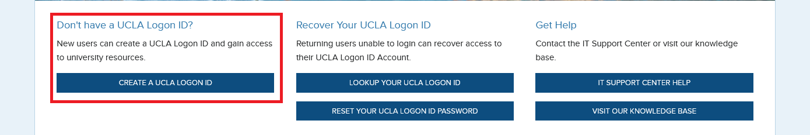

- Generate your UID by clicking the “I do not have a 9 digit UCLA ID number (UID)”.
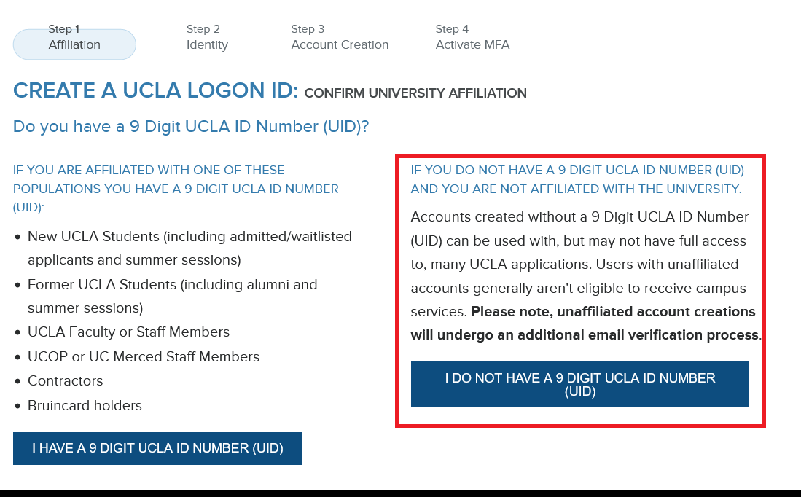

- Verify your account and (optionally) activate MFA (DUO).
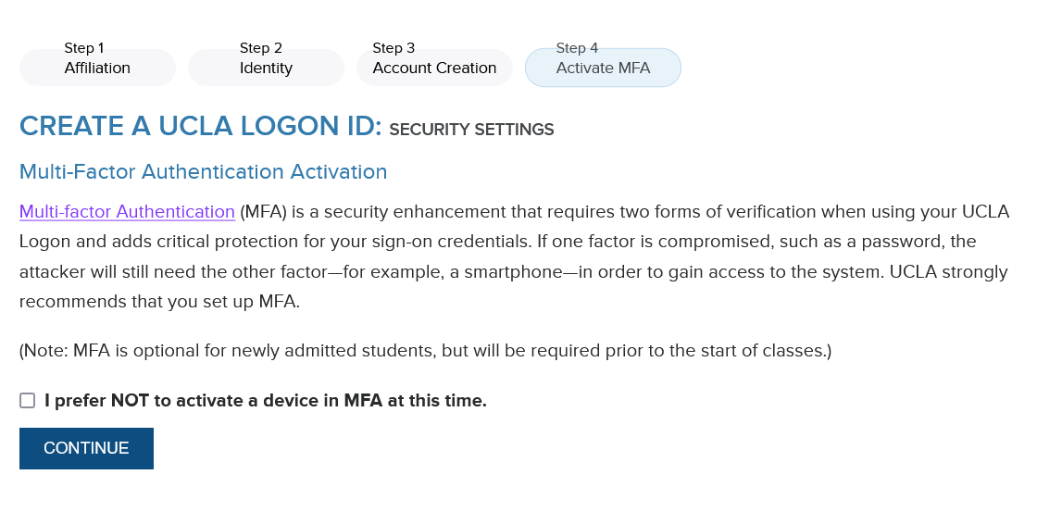

- If necessary, have an AIR-P staff member request a University ID Number (UID) for you. Please provide your UCLA Login ID with this request. Otherwise – you’re set!

